**Khyber Pakhtunkhwa Human Capital Investment Project**

**Monitoring visit report of ECE Rooms**

**District Swabi**

**Visit Date:** June 14, 2023

**District:** Swabi

**Visiting Team:**  Khizar Dawood (M&E Officer), Badshah Khan (Program Officer)

**Visit Objective:** Monitoring Visit of ECE rooms

**Report Prepared By:** Khizar Dawood (M&E Officer)

Khyber Pakhtunkhwa Human Capital Investment Project (KP-HCIP) Education Component is designed to improve availability, utilization and quality of education services in the districts of Khyber Pakhtunkhwa. Project focuses on to cater the needs of high number of Out Of School Children (OOSC) in host as well Afghan Refugee communities. To achieve the objective under Non-Formal Basic Education (NFBE), establishment of 1000 Early Childhood Education (ECEs) rooms proposed to be established to provide grass root level of education and counter contributing factors for OOSC. The support will enable them to join mainstream schooling in later stages. These centers are planned to be established in two phases. In phase-I, it is planned to establish rooms in Peshawar (98), Nowshera (102), Swabi (104) and Haripur (142).

***During the visit, 02 ECE rooms in District Swabi visited, details are;***

|  |  |  |  |  |  |
| --- | --- | --- | --- | --- | --- |
| Sr# | *School Name* | *EMIS Code* | *Gender* | *Tehsil* | *Locality* |
| 01 | *GPS# 01 Yar Hussain* | *23860* | *Male* | *Rajjar* | *Rural* | |
| 02 | *GPS# 03, Yar Hussain* | *23862* | *Male* | *Rajjar* | *Rural* | |

***\* Details are given accordingly in later section of the report.***

# **01. GPS# 01, Yar Hussain, EMIS Code# 23860**

|  |
| --- |
| ***Table-A: Learners Information Related to ECE*** |

|  |  |  |  |  |
| --- | --- | --- | --- | --- |
| **Total Enrollment** | **Afghan Refugee Enrollment** | **Total Local learners** | **Boys** | **Girls** |
| 35 | 00 | 35 | 25 | 10 |

* ECE rooms establishment was under process. Till visit day wall panel work was observed completed. Vendor was instructed to change (replace) the front wall panel (blue color), which was not done and required to replace as instructed. Apart from the wall panel, supply of partial items been done. Details are;

|  |
| --- |
| ***Table-B: Supplied Items Information*** |

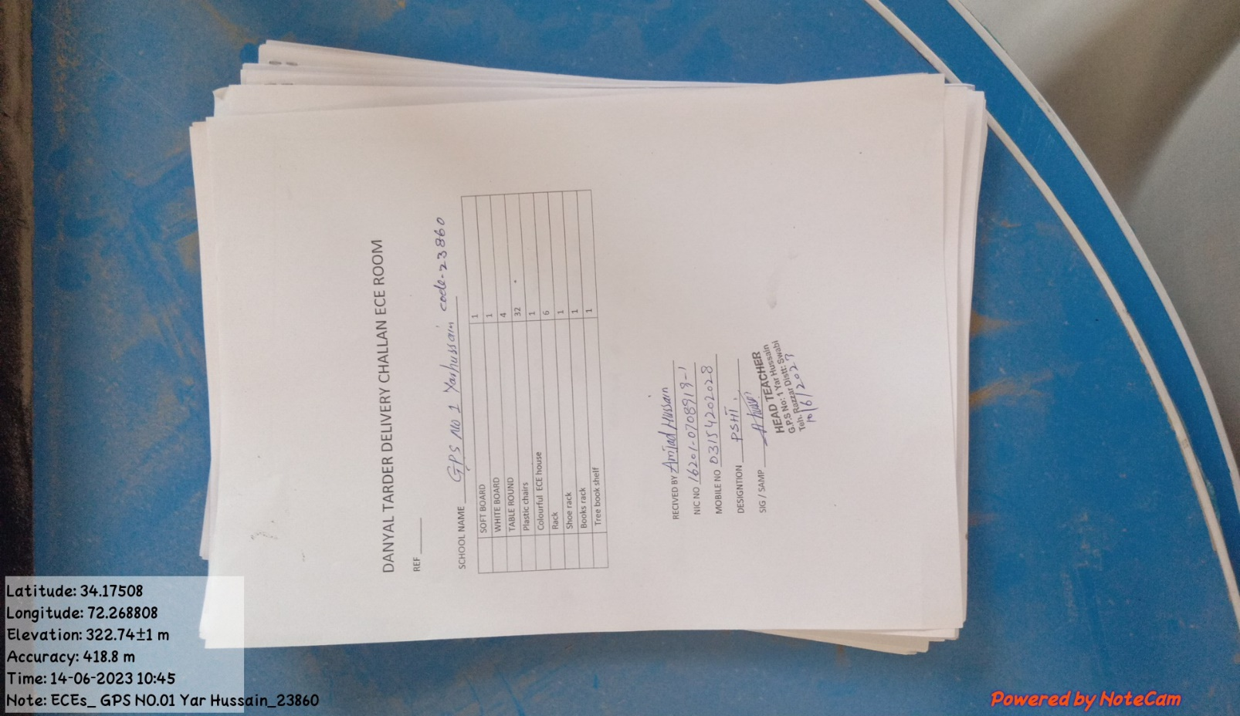

**Figure# 1: Signed receiving of supplied items to school administration, GPS# 01, Yar Hussain**

|  |  |  |
| --- | --- | --- |
| ***SR#*** | ***Items supplied*** | ***Quantity*** |
| *01* | *Student Chairs (R,G,B colors)* | *32* |
| *02* | *Student Tables* | *04* |
| *03* | *White board* | *01* |
| *04* | *Soft Board (Green color)* | *01* |
| *05* | *Colorful ECE House* | *01* |
| *06* | *Rack* | *06* |
| *07* | *Books Rack* | *01* |
| *08* | *Shoe Rack* | *01* |
| *09* | *Tree Book Shelf* | *01* |
| *10* | *Floor Mat* | *Provided* |

* It was observed that Floor mat was provided but not placed on the floor till visit day. According to the staff member, the floor will be placed in last once the supplies completed in all aspect.
* It was shared by the staff member that before we had no proper facilities for the early education, the children used to attend the school informally and school administration barely meet their learning requirements. Now, after the establishment of ECE room and provision of basic learning material, we are in a position to not only enroll the students but also provide them basic education facilities. The establishment of ECE room will promote pre-schooling in the community, build trust of the parents and also promote education as well.

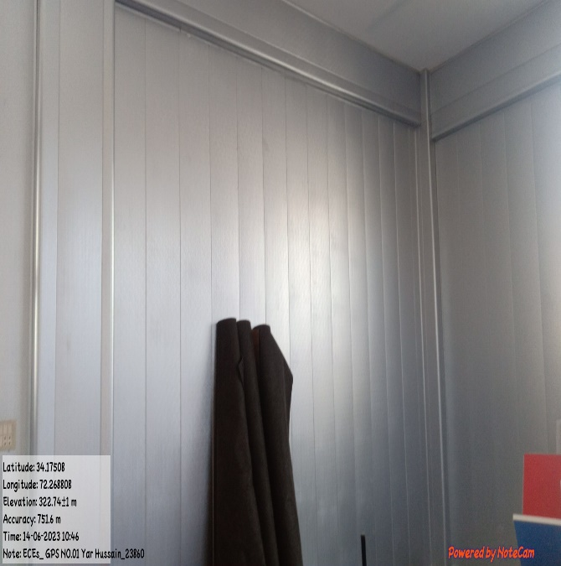

**Figure#03: Floor mats provided but not placed till visit day**

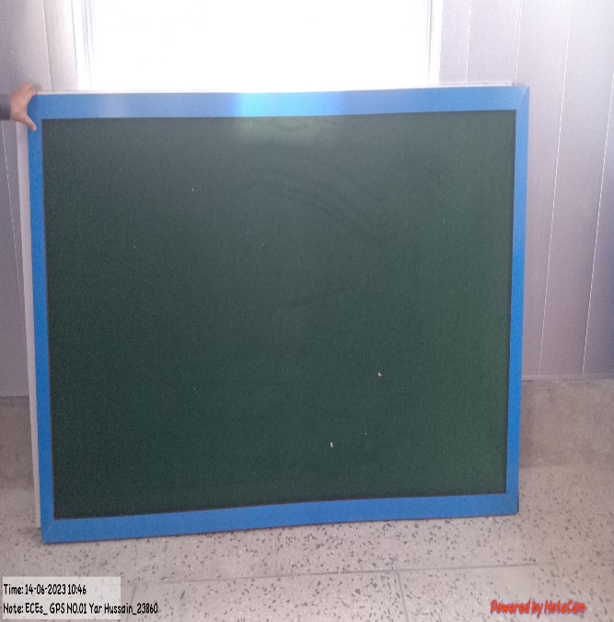

**Figure#02: Green board provided but not yet installed till visit day**

* It was observed that ECE room was enough spacious to carry out regular learning activities, despite of being placed all the items students and teachers will not have problem in managing seating and mobility needs.

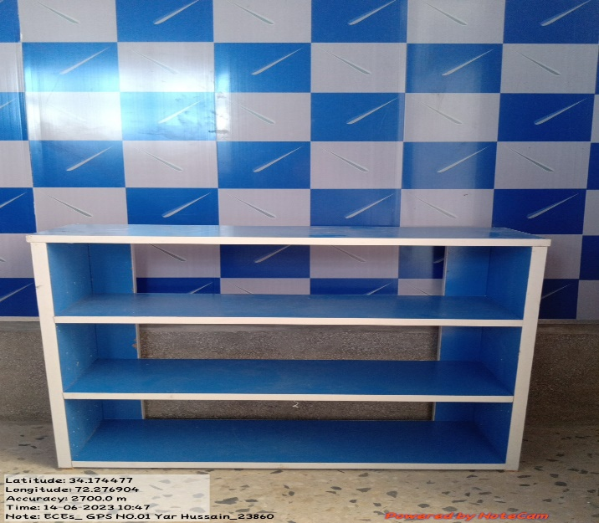

**Figure#06: Shoe rack provided to ECE room**

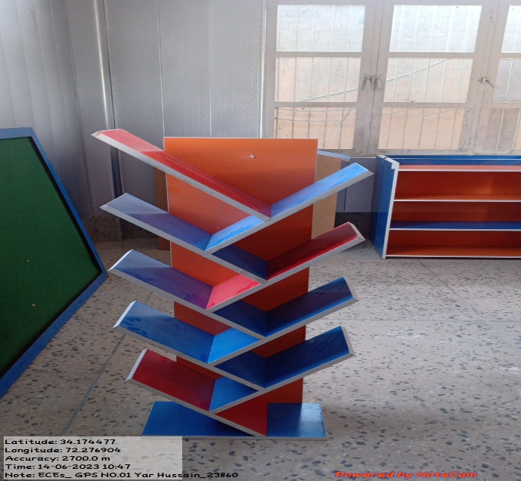

**Figure#07: Tree book shelf provided to ECE room**

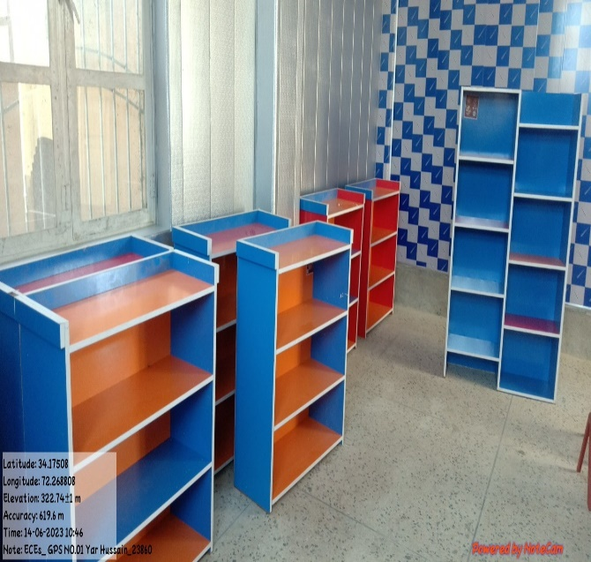

**Figure#05: View of provided racks and book rack**

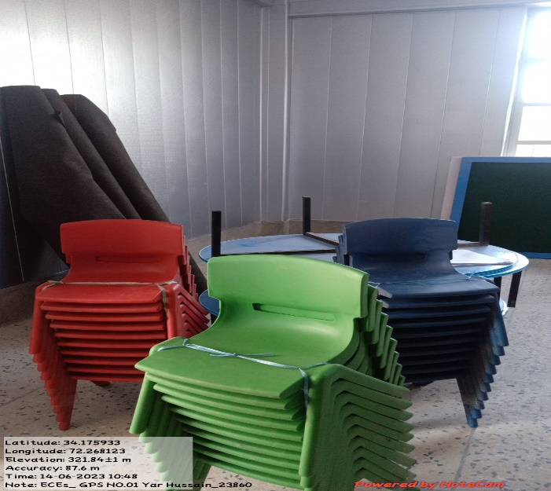

**Figure#04: View of Students chairs and tables**

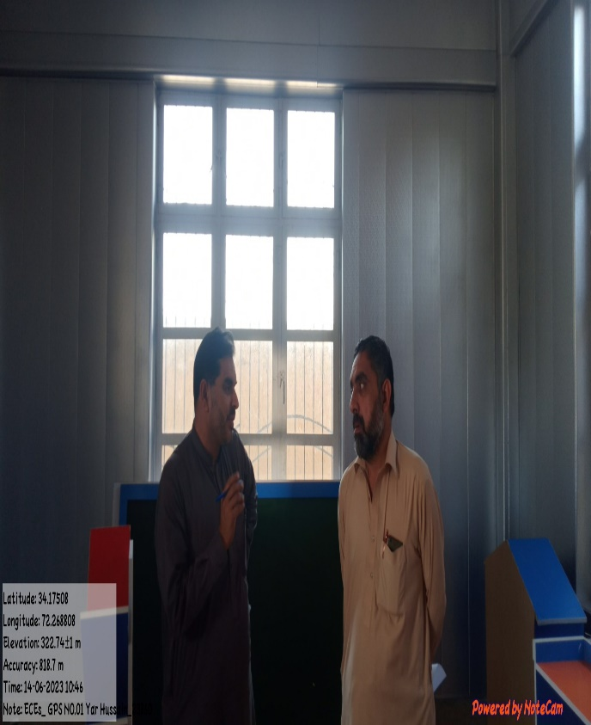

**Figure#08: Badshah Khan collects feedback from the teacher during the visit**

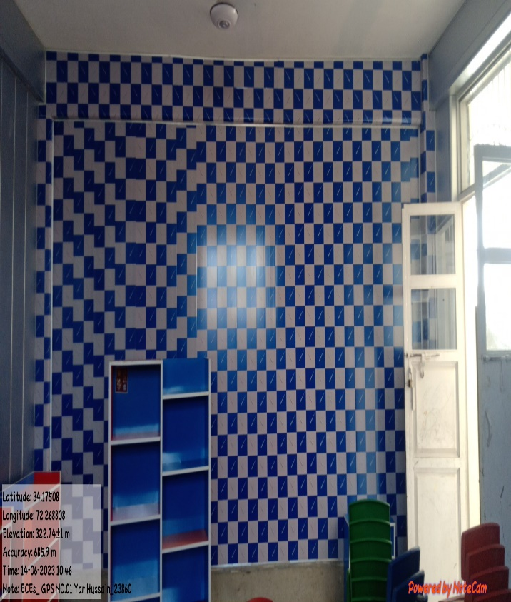

**Figure# 07: View of front wall (required to replace)**

# **02. GPS# 03, Yar Hussain, EMIS Code# 23862**

|  |
| --- |
| ***Table-A: Learners Information related to ECE*** |

|  |  |  |  |  |
| --- | --- | --- | --- | --- |
| **Total Enrollment** | **Afghan Refugee Enrollment** | **Total Local learners** | **Boys** | **Girls** |
| 27 | 00 | 27 | 27 | 00 |

* ECE rooms establishment was under process. Till visit day wall panel work was observed completed. Vendor was instructed to change (replace) the wall panel (blue color), which was not done and required to replace as instructed. Apart from the wall panel, supply of partial items been done. Details are;

|  |
| --- |
| ***Table-B: Supplied Items Information*** |

|  |  |  |
| --- | --- | --- |
| ***SR#*** | ***Items supplied*** | ***Quantity*** |
| *01* | *Student Chairs (R,G,B colors)* | *32* |
| *02* | *Student Tables* | *04* |
| *03* | *White board* | *01* |
| *04* | *Soft Board (Green color)* | *01* |
| *05* | *Colorful ECE House* | *01* |
| *06* | *Rack* | *06* |
| *07* | *Books Rack* | *01* |
| *08* | *Shoe Rack* | *01* |
| *09* | *Tree Book Shelf* | *01* |
| *10* | *Floor Mat* | *Provided* |

* Floor mat was supplied, but not placed on the floor till visit day. Security guard shared, administration staff will decided to place the floor mat, and it is probably will be placed once the rest of the supplies completed in all aspect.
* It was observed that ECE room was enough spacious to carry out regular learning activities, despite of being placed all the items students and teachers will not have problem in managing seating and mobility needs.

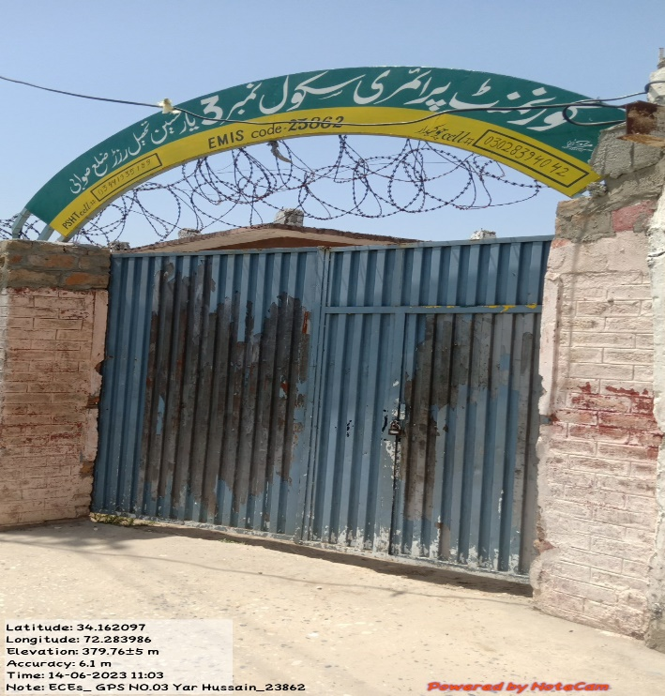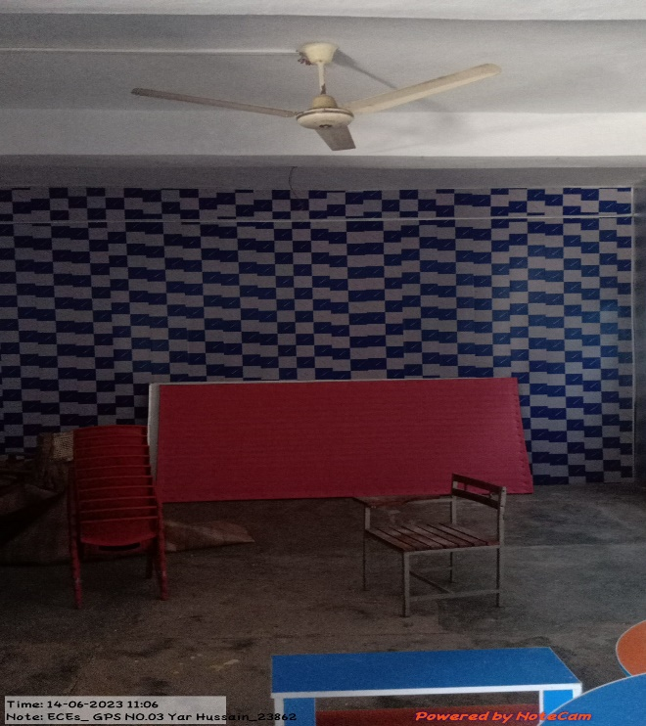

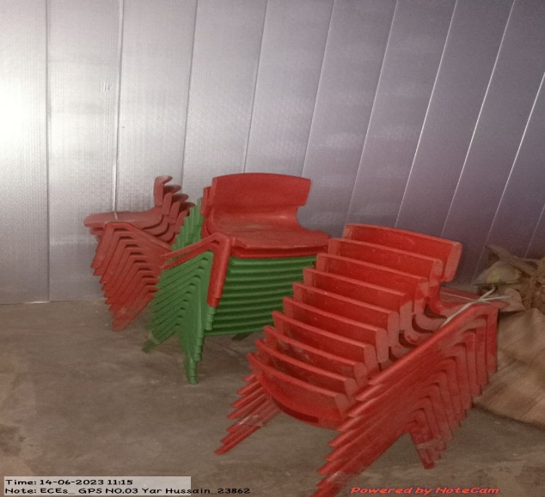

**Figure#04: View of multi-color students chairs provided to ECE room**

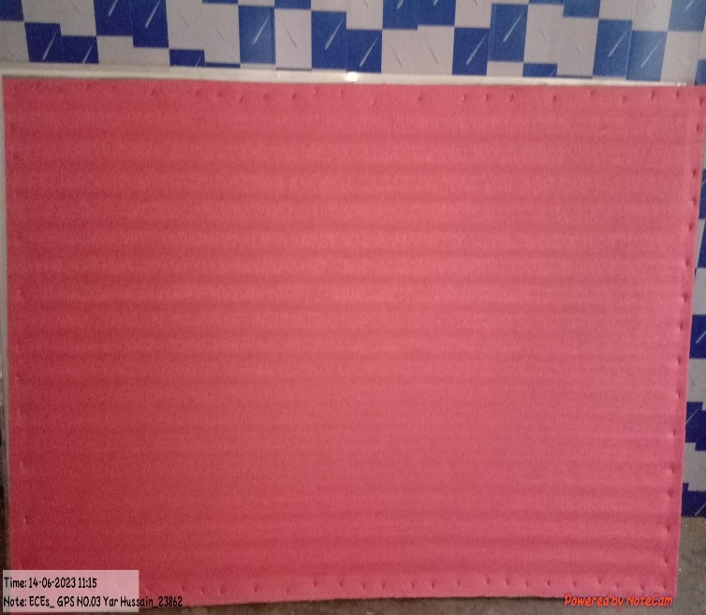

**Figure#03: Soft board provided but not yet installed till visit day**

**Figure# 02: View of wall panel which is not been replaced till visit day**

**Figure# 01: GPS# 03, Yar Hussain, EMIS # 23862 visited**

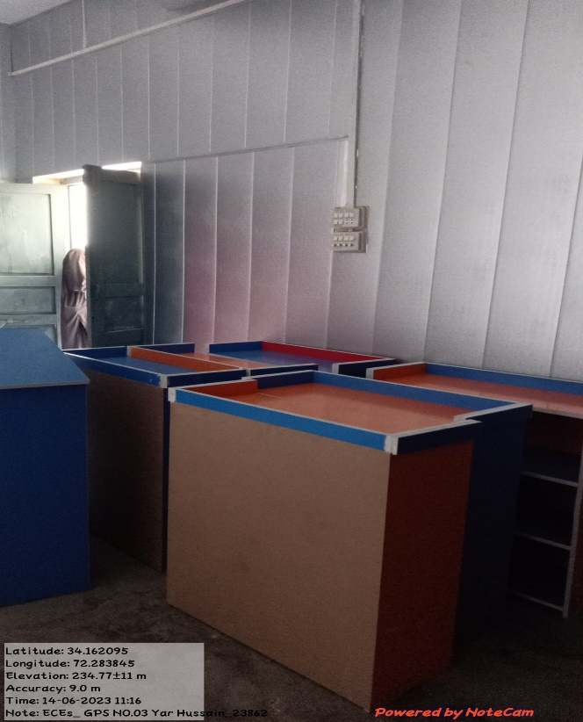

**Figure# 08: Book racks provided to ECE room**

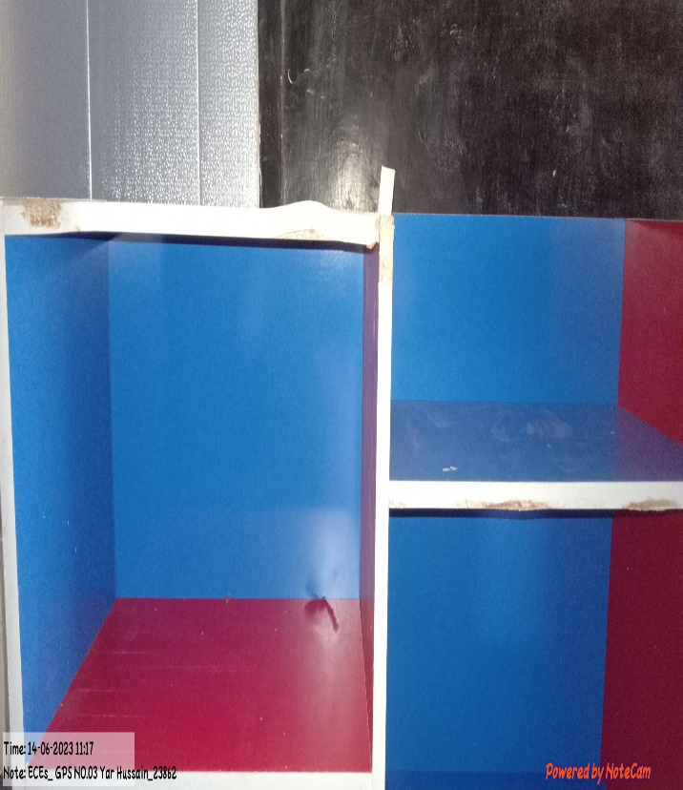

**Figure# 07: Shoe rack provided to ECE room**

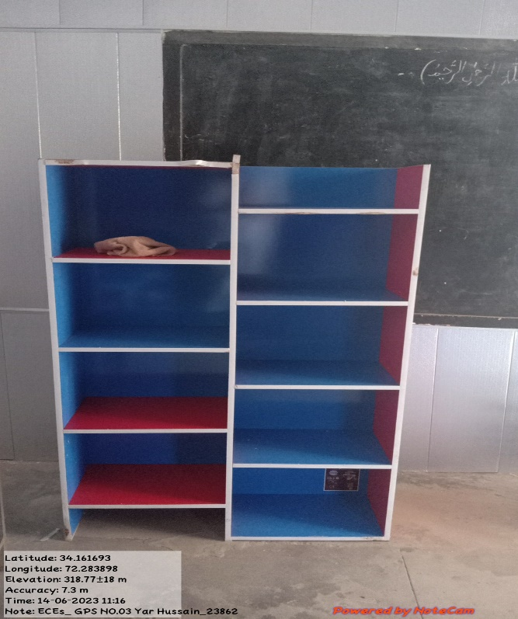

**Figure# 06: View of provided racks to ECE room**

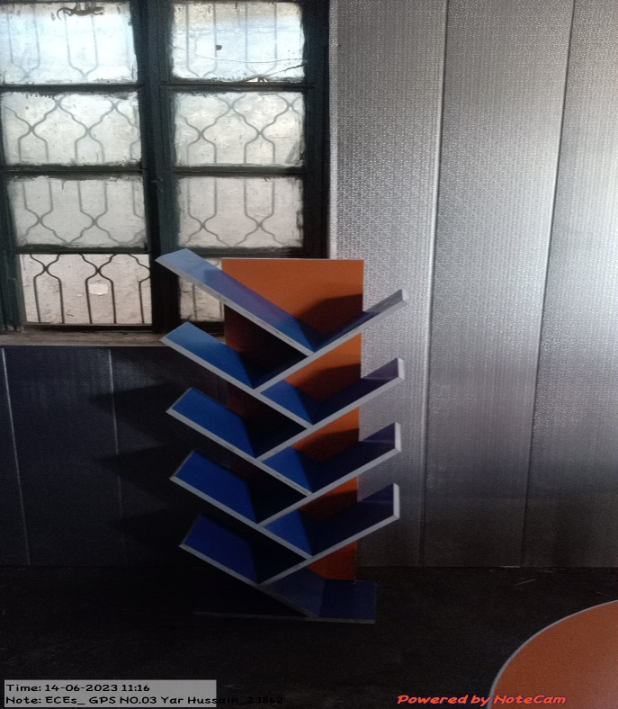

**Figure# 05: View of provided ECE tree book shelf**

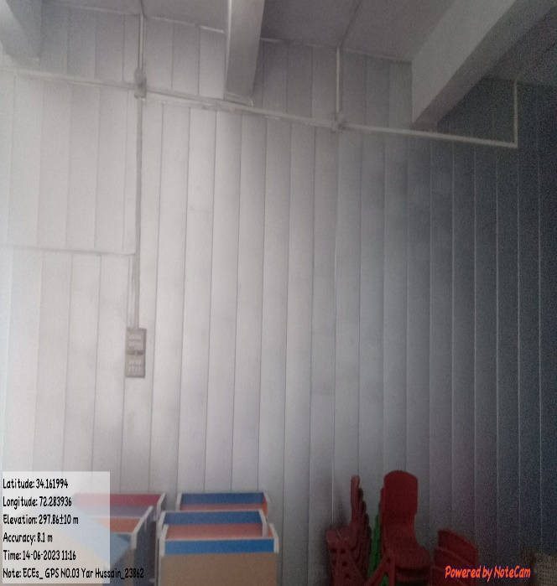

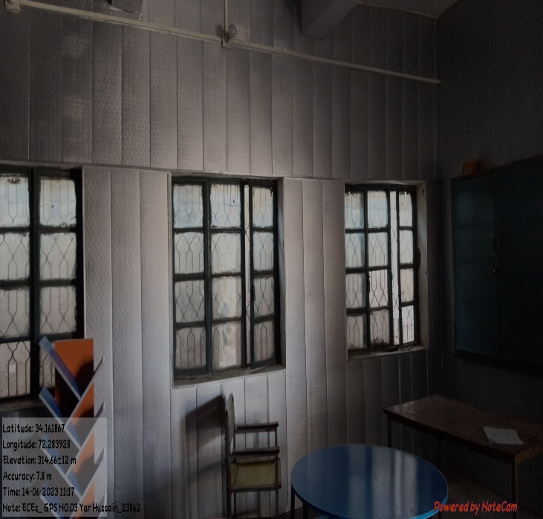

**Figures# 11 & 12: Interior views of ECE room**

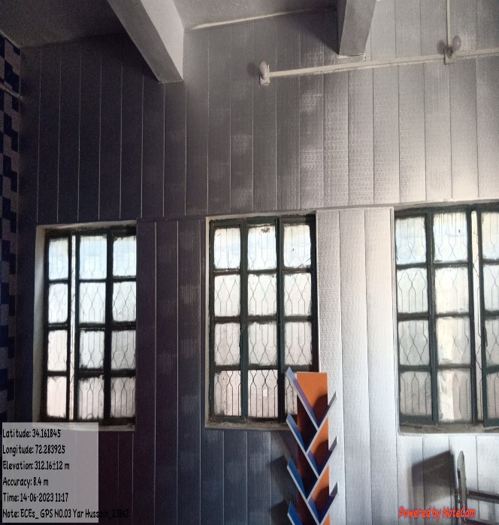

**Figure# 10: Another view of ECE room**

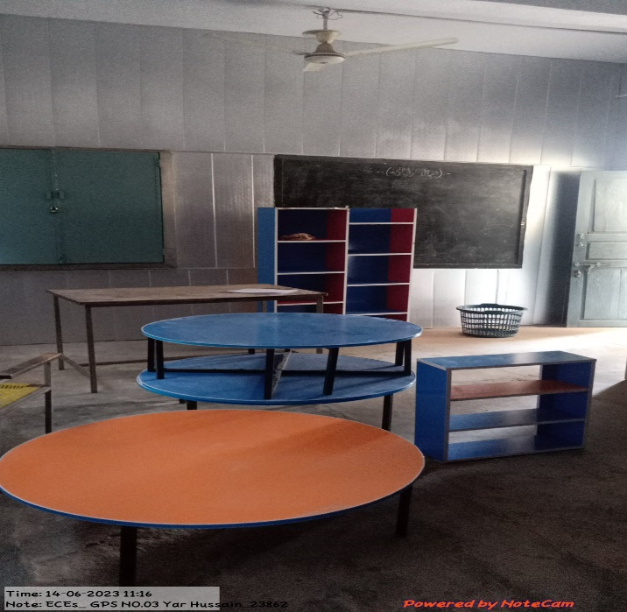

**Figure# 09: View of provided students tables to ECE room**